ABSTRACT TITLE
Johns I. ¹, Johnson P. ²
¹ Affiliation 1, City, Country
² Affiliation 2, City, Country
email1@example.com, email2@example.com
Page parameters: A4 format, 2 cm margins. The abstract text should be in Times New Roman, 10 pt, single line spacing, and 1 cm paragraph indentation. Figures with captions (caption font size – 10 pt) should be embedded into the text; format of the caption: Fig. 1. The name of the figure.

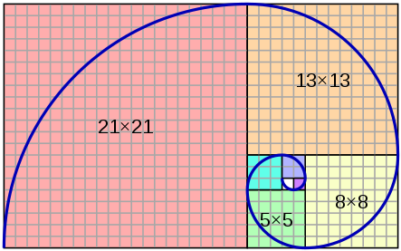
Fig. 1. The name of the figure

References should be arranged according to GOST R 7.0.5 – 2008 [1]. The list is formed in the order of mention in the text, size 9 pt. References to figures from the text are required.
The abstract should not exceed one page in length. File name: “Johns Johnson.doc”
Literature
- GOST Р 7.0.5—2008. Bibliographic reference. General requirements and rules of making. Moscow, 2008. 23 p. (System of standards on information, librarianship and publishing).
- Johnson J.J. Book title. Moscow: World publishing, 2018. 321 p.
- Jackson C.C. Paper title // Journal name. 2018. №1. P. 56-61.
- Awkwardson B. Paper title // Proceedings title / edited by. J.P. Swanson. City: Publishing, 2018. P. 230-236.

